CALGARY COPD & ASTHMA PROGRAM (CCAP) – Community Education
HOW TO MAKE A REFERRAL IN CONNECT CARE

Adult patients that require respiratory education in the community who are diagnosed with asthma, COPD or smokers at risk. Any further inquiries or need assistance with making a referral please contact 587-779-2068.
- Enter a new Order
- Find & select patient
- At the bottom left + ADD Order, type in Ambulatory Referral to Pulmonary/Respiratory. Enter and Accept

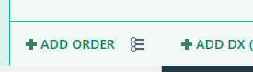

- The order composer pops up, fill out the following. All hard stops must be completed.

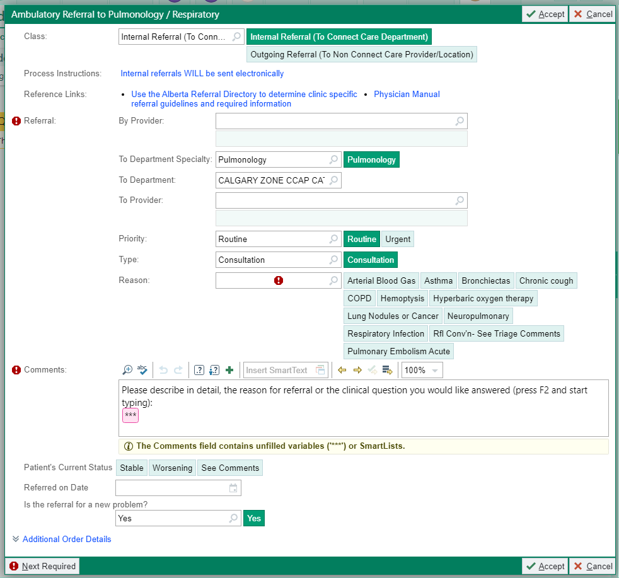a

By Provider: Your name
To Dept: Calgary Zone CCAP CAT
Reason: Select appropriate reason e.g. Asthma
Comments: Type over the 3 dots e.g. Patient needs education for asthma management
Referral Date: today’s date
- Accept
- Sign Order (bottom right hand side) – select your name. If you are not able to be the Authorizing Provider, enter External – Allied Health
- Accept
- Notification to your inbasket that CCAP received your referral
- Notification to your inbasket to cosign order.

